WELSH LANGUAGE DEVELOPMENT

Area / Theme: ON THE FARM

Song: Ar Fferm y Foel

Adult Directed / Focused

- Introduce the following vocabulary:

hwyaden | - | duck |  | hwyaid | - | ducks
dafad | - | sheep |  | defaid | - | sheep
buwch | - | cow |  | gwartheg | - | cows
mochyn | - | pig |  | moch | - | pigs

- Introduce the following language patterns:

hwyaid llon yn cwacian | - | ducks are quacking
defaid llon yn brefu | - | sheep are bleating
gwartheg llon yn brefu | - | cows are lowing
mochyn llon yn rhochian | - | pig is grunting

Children to suggest actions to go with the above.
- Encourage the children to respond using the actions and the animal sounds whilst listening to the song.

Adult Supported / Enhanced

- Encourage the children to participate in the activity. Use the following language patterns:

Clicia yma. | - | Click here.
eto | - | again
Gwranda. | - | Listen.
Wedi gorffen. | - | Finished.

Adult Observed / Continuous

- Provide ample opportunities for individual children to use the above activity.
- In pairs, one child could take on the role of the teacher / practitioner using language from Adult Supported / Enhanced.

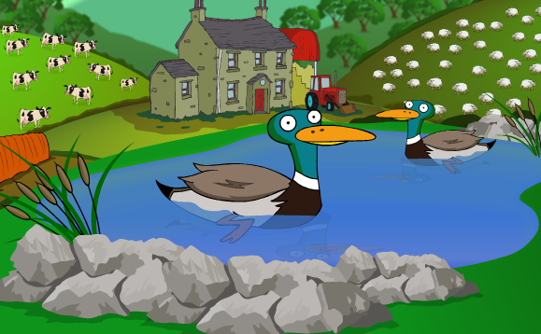
Area / Theme: ON THE FARM

Activity 1: Mathematical Development

Adult Directed / Focused

- Click on the number – 1 or 2.
Number 1
- Screen opens with pictures of the following animals:
mochyn | - | pig |  | dafad | - | sheep
hwyaden | - | duck |  | buwch | - | cow

- Click on the sound icon to hear the vocabulary.
- By clicking on the animals one at a time, they will appear in the field. The corresponding number will be heard and seen in the sun. You can also click on the animals in the field.
- You can count one type of animal e.g. mochyn or a combination of the animals.
- Create plenty of opportunities to give the children specific tasks:
‘Rhowch bump mochyn yn y cae.’ | - | Put five pigs in the field.
‘Rhowch chwech anifail yn y cae.’ | - | Put six animals in the field.
- Encourage the children to count with you.
- By clicking on the red arrow you return to the initial screen.
Number 2
- Listen and read the question on the screen.

Sawl hwyaden sydd yn y cae? | - | How many ducks are in the field?
Sawl buwch sydd yn y cae? | - | How many cows are in the field?
Sawl dafad sydd yn y cae? | - | How many sheep are in the field?
Sawl mochyn sydd yn y cae? | - | How many pigs are in the field?

- Encourage the children to count with you and to find the number symbol on the bottom of the screen.
- If correct you will continue to the next screen. If incorrect the number symbol will turn grey.

Adult Supported / Enhanced

- Encourage the children to participate in the activity.
- Use the following language patterns:

Clicia yma. | - | Click here.
eto | - | again
Ble mae 5? | - | Where is 5?
Beth sydd nesaf? | - | What’s next?

Adult Observed / Continuous

- Provide ample opportunities for individual children to use the above activity.
- In pairs, one child could take on the role of the teacher / practitioner using language from Adult Supported / Enhanced.

Area / Theme: ON THE FARM

Activity 2: Creative Development

Adult Directed / Focused

- Listen to the instruction:

Peintia’r mochyn yn binc. | - | Paint the pig pink.
Peintia’r hwyaden yn felyn. | - | Paint the duck yellow.
Peintia’r fuwch yn ddu. | - | Paint the cow black.
Peintia’r ddafad yn wyn. | - | Paint the sheep white.

and click on the correct paint pot. A paint brush will appear then click on the animal.
- By choosing the correct colour, an animation of the animal will appear and you will progress to the next screen. If incorrect, there is no animation.

Adult Supported / Enhanced

- Encourage the children to participate in the activity.
- Use the following language patterns:

Clicia yma. | - | Click here.
Pa liw? | - | Which colour?
melyn / gwyn / pinc / du | - | Yellow / white / pink / black
Da iawn. | - | Very good.
Hen dro. Tria eto. | - | What a pity. Try again.

Adult Observed / Continuous

- Provide ample opportunities for individual children to use the above activity
- In pairs, one child could take on the role of the teacher / practitioner using language from Adult Supported / Enhanced.

Area / Theme: ON THE FARM

Activity 3: Knowledge and Understanding of the World

Adult Directed / Focused

- Listen to the instruction:
‘Clicia a gwranda. Pa anifail?’ – Click and listen. Which animal?

- Click on the sound icon to hear the animal sound.
- Encourage the children to match the sound with one of the animal pictures at the bottom of the screen.
- If correct, a larger picture of the animal will appear and you will progress to the next screen.
- If incorrect, the picture of the animal will turn grey and the sound of the chosen animal will be heard.

Adult Supported / Enhanced

- Encourage the children to participate in the activity.
- Use the following language patterns:

Clicia a gwranda. | - | Click and listen.
Pa anifail? | - | Which animal?
Clicia yma. | - | Click here.
Beth sydd nesaf? | - | What’s next?
Hen dro. Tria eto. | - | What a pity. Try again.

Adult Observed / Continuous

- Provide ample opportunities for individual children to use the above activity.
- In pairs, one child could take on the role of the teacher / practitioner using language from Adult Supported / Enhanced.

Area / Theme: ON THE FARM

Activity 4

Interactive games for children - Dominoes.

Instructions how to play:

- Choose one of the three picture dominoes at the bottom of the screen to correspond with the picture domino in the centre of the screen.
- If correct you carry on matching the dominoes until the game has finished
‘Wedi gorffen. Da iawn.’
- If incorrect the domino will revert to its original place.

Points to remember:

- Encourage the children to participate in the activity.
- Provide ample opportunities for individual children to use the above activity.
- In pairs, one child could take on the role of the teacher / practitioner using language from Adult Supported / Enhanced.

